**PRE1 BIP Server AWS Migration**

By: Evan Lai

Date: 02/22/2019

Version: 1.0

**Part 1: OS Preparation**

Execute steps below as os “root” account.

**1.1 Create jboss os user:**

useradd -u xxx jboss

Note: Please use the same jboss user id number from the source .

**1.2 Configure /etc/hosts file as below:**

127.0.0.1 localhost localhost.localdomain

10.51.1.17 ppre1bipappin1.aws-p-pre.copyright.com ppre1bipappin1

**1.3 Check /etc/sysconfig/network file as below:**

NOZEROCONF=true

HOSTNAME=ppre1bipappin1.aws-p-pre.copyright.com

NETWORKING=yes

RES_OPTIONS="single-request-reopen"

**1.4 Set jboss os user password and record it to password system**

passwd jboss

**1.5 Add the following entry to the end of /etc/ssh/sshd_config file.**

AllowGroups root nonprodlinuxqa jboss

# Example of overriding settings on a per-user basis

#Match User anoncvs

# X11Forwarding no

# AllowTcpForwarding no

# PermitTTY no

# ForceCommand cvs server

Match User jboss

PasswordAuthentication yes

**1.6 Restart sshd:**

service sshd restart

**Part 2: Security Group Preparation**

**2.1 Confirm or update security group:** [bip-ppre-int](https://console.aws.amazon.com/ec2/v2/home?region=us-east-1#SecurityGroups:groupId=sg-0b963be44c9511f46;sort=groupId)

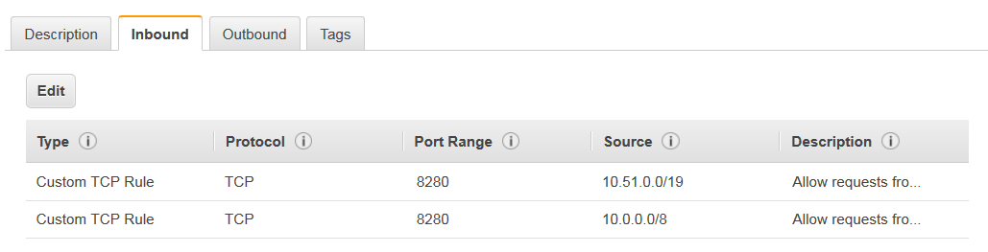

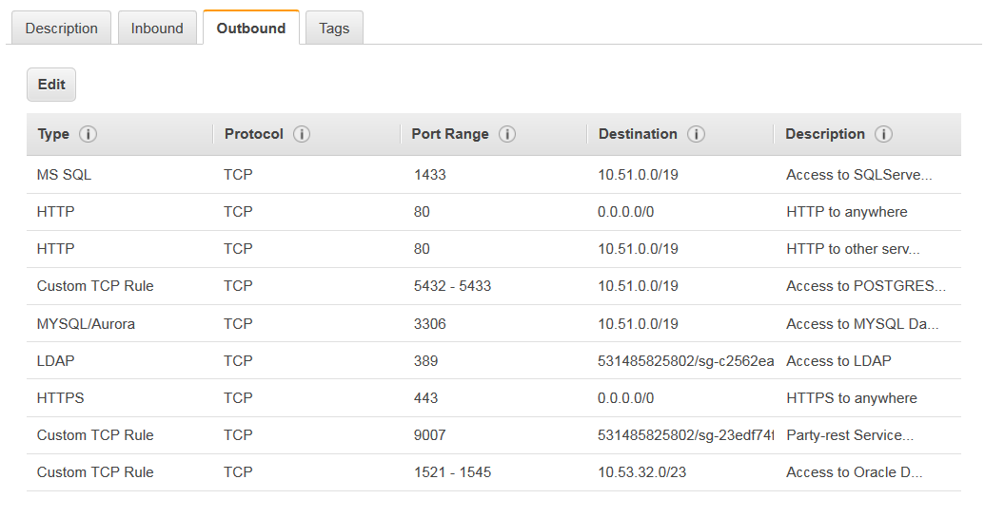

**Part 3. BIP Server AWS Migration:**

**3.1 Run as “jboss” os account from the source host:**

[jboss@pre1bipin1 bin]$ cd /home/jboss/bin

[jboss@pre1bipin1 bin]$ ./stopINTTBIPPRE1.sh

3704

3771

Shutting down the server

….....................................................................................................................Attempting to kill JBOSS processes 3704 3771 (Jboss)

PROCCNT 0

PROCCNT 0

Jboss Server shutdown.

[jboss@pre1bipin1 bin]$

**3.2 Copy source files from the source to target:**

[jboss@pre1bipin1 ~]$ cd /home/jboss

[jboss@pre1bipin1 ~]$ scp INTBIPPRE1ENV [jboss@ppre1bipappin1.aws-p-pre.copyright.com:/home/jboss](mailto:jboss@ppre1bipappin1.aws-p-pre.copyright.com:/home/jboss)

[jboss@pre1bipin1 ~]$ scp -r bin [jboss@ppre1bipappin1.aws-p-pre.copyright.com:/home/jboss](mailto:jboss@ppre1bipappin1.aws-p-pre.copyright.com:/home/jboss)

[jboss@pre1bipin1 u01]$ cd /u01

[jboss@pre1bipin1 u01]$ tar cpfz pre1.tgz ./pre1

[jboss@pre1bipin1 u01]$ scp pre1.tgz [jboss@ppre1bipappin1.aws-p-pre.copyright.com:/u01](mailto:jboss@ppre1bipappin1.aws-p-pre.copyright.com:/u01)

[jboss@pre1bipin1 u01]$ cd /u02

[jboss@pre1bipin1 u02]$ tar cpfz pre1.tgz ./pre1

[jboss@pre1bipin1 u02]$ tar cpfz download.tgz ./download

[jboss@pre1bipin1 u02]$ scp pre1.tgz [jboss@ppre1bipappin1.aws-p-pre.copyright.com:/u02](mailto:jboss@ppre1bipappin1.aws-p-pre.copyright.com:/u02)

[jboss@pre1bipin1 u02]$ scp download.tgz [jboss@ppre1bipappin1.aws-p-pre.copyright.com:/u02](mailto:jboss@ppre1bipappin1.aws-p-pre.copyright.com:/u02)

**3.3 Unzip files as “jboss” os account at the target host**

cd /u01

[jboss@ppre1bipappin1 u01]$ tar xpfz pre1.tgz

cd /u02

[jboss@ppre1bipappin1 u02]$ tar xpfz pre1.tgz

**3.4 Configure environment file:**

Edit the environment file /home/jboss/INTBIPPRE1ENV. Point the Java Home as below

export JAVA_HOME=/u01/java/java-1.5.0-sun-1.5.0.15

**3.5 Test start up and shut down scripts:**

cd bin

[jboss@ppre1bipappin1 bin]$ ./startINTBIPPRE1.sh

[jboss@ppre1bipappin1 bin]$ ./stopINTTBIPPRE1.sh

**3.6 Startup BIP server and test/modify Data Sources:**

Login to URL below as “CCC_SU” user. Record the new URL and login credentials to the password system.

http:// ppre1bipappin1.aws-p-pre.copyright.com:8280/xmlpserver

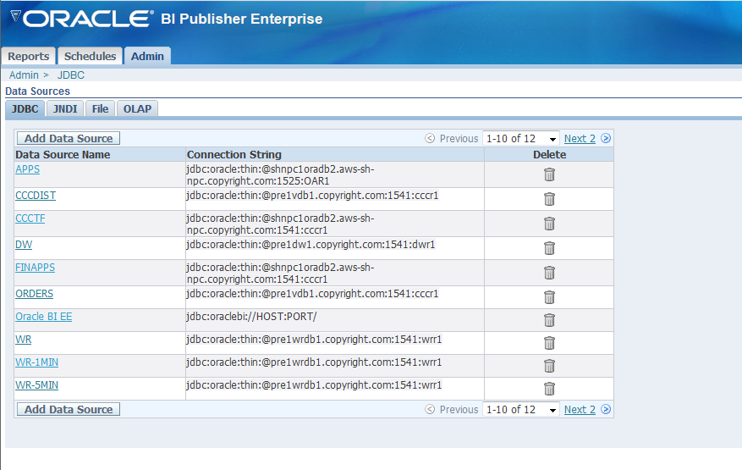

**3.7 Restart BIP Server:**

cd bin

[jboss@ppre1bipappin1 bin]$ ./startINTBIPPRE1.sh

[jboss@ppre1bipappin1 bin]$ ./stopINTTBIPPRE1.sh